Kyle Klausen

CSD-325

Assignment4_2

06/13/25

Original flowchart:

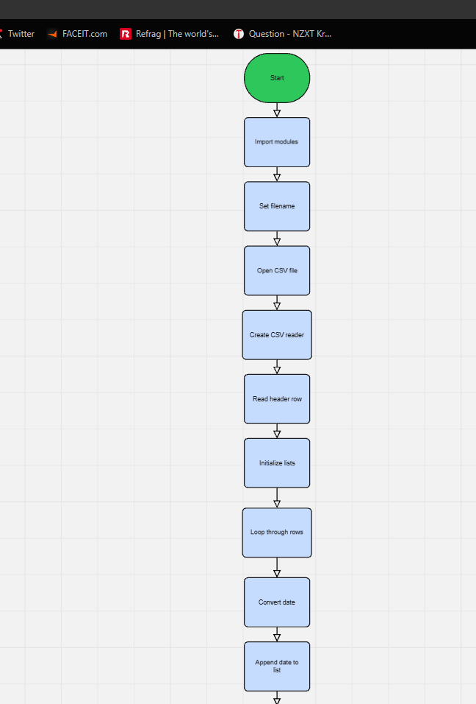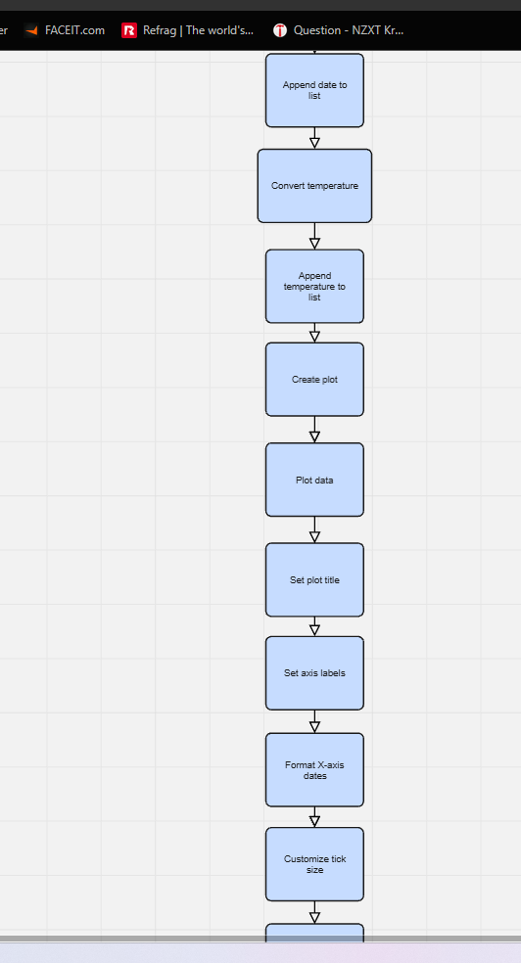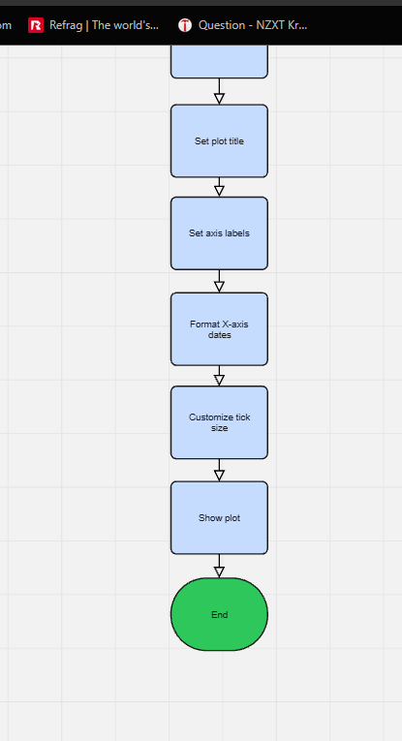

Revised Flowchart:

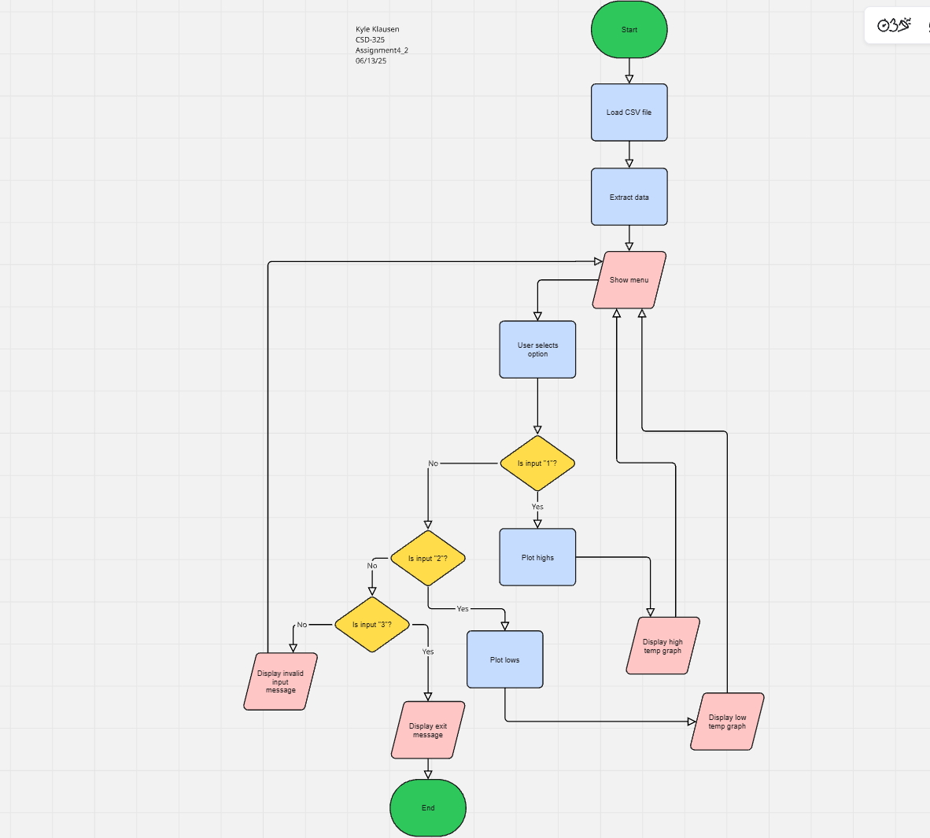

Python Code:

# Author - Kyle Klausen

# Assignment4_2

# Date - 06/12/25

# Description: Below is a program designed to help people gain

# insight / data from some provided charts. This is provided through user input.

import csv

import sys

from datetime import datetime

from matplotlib import pyplot as plt

# Load data from the CSV file

filename = 'C:/Users/Kyle/Documents/CSD-325 Python Projects/sitka_weather_2018_simple.csv'

with open(filename) as f:

reader = csv.reader(f)

header_row = next(reader)

dates, highs, lows = [], [], []  
 for row in reader:  
 current_date = datetime.strptime(row[2], '%Y-%m-%d')  
 try:  
 high = int(row[5])  
 low = int(row[6])  
 except ValueError:  
 print(f"Missing data for {current_date}")  
 else:  
 dates.append(current_date)  
 highs.append(high)  
 lows.append(low)

# Start interactive loop

while True:

print("\n--- Sitka Weather Data Viewer ---")

print("1: View High Temperatures")

print("2: View Low Temperatures")

print("3: Exit")

choice = input("Enter your choice (1/2/3): ").strip()  
  
if choice == '1':  
 # Plot high temperatures  
 fig, ax = plt.subplots()  
 ax.plot(dates, highs, c='red')  
 plt.title("Daily High Temperatures - 2018", fontsize=24)  
 plt.xlabel('', fontsize=16)  
 fig.autofmt_xdate()  
 plt.ylabel("Temperature (F)", fontsize=16)  
 plt.tick_params(axis='both', which='major', labelsize=16)  
 plt.show()  
  
elif choice == '2':  
 # Plot low temperatures  
 fig, ax = plt.subplots()  
 ax.plot(dates, lows, c='blue')  
 plt.title("Daily Low Temperatures - 2018", fontsize=24)  
 plt.xlabel('', fontsize=16)  
 fig.autofmt_xdate()  
 plt.ylabel("Temperature (F)", fontsize=16)  
 plt.tick_params(axis='both', which='major', labelsize=16)  
 plt.show()  
  
elif choice == '3':  
 print("\nThank you for using the Sitka Weather Data Viewer. Goodbye!")  
 sys.exit()  
  
else:  
 print("Invalid input. Please choose 1, 2, or 3.")

Screenshots of successful run:

